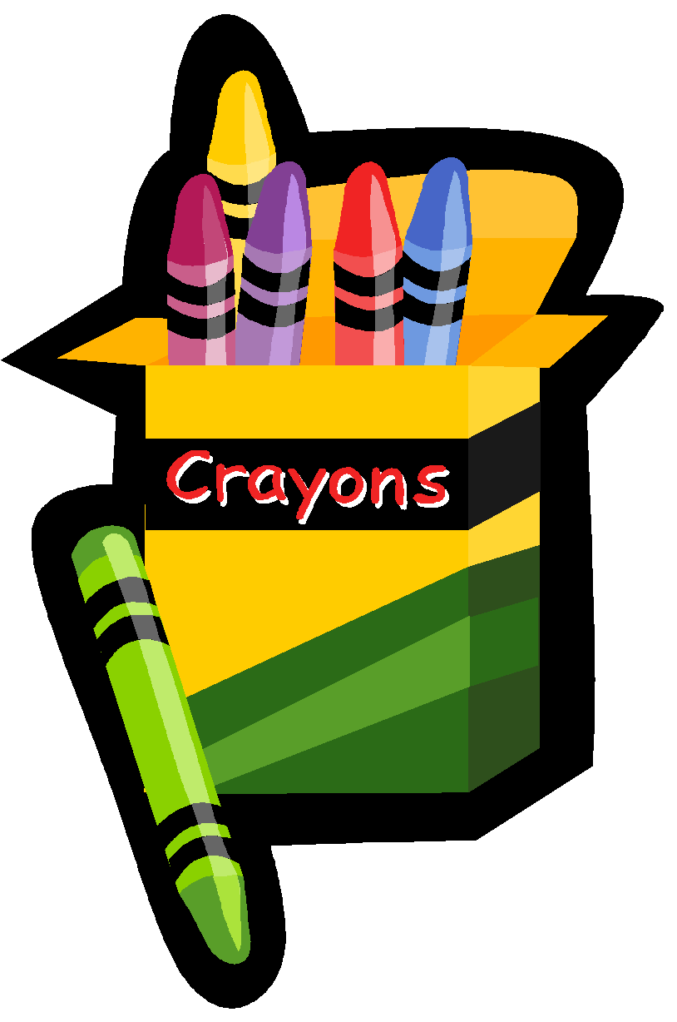
Incoming Kindergarten Supply List
2023-2024

Your child will need the following supplies for the first day of school in September. Please label a large Ziploc bag with your child’s first and last name and place all supplies in the bag.

Item Quantity
1. Crayola Primary color Twistables –24 count 2
2. .77 oz Large Elmer's Glue Stick 4
3. Two vinyl/plastic pocket folders 2
4. Crayola 8 count watercolor paint set 1
5. Black dry erase markers 2
6. Anti-microbial vinyl rest mat 1
(no bigger than1 inch x 19 inch x 45 inch)
7. Child scissors 1
8. Lysol / Clorox antibacterial wipes 1 container
9. Zipper pencil bag 2
10. My First Ticonderoga Woodcase Primary Fat Pencil with eraser 1 package

Must be purchased on your own:
11. Inexpensive headphones in labeled ziploc bag 1
12. Art smock, labeled 1
13. Ziploc Big Bags XXL Double Zipper 20 gallon, labeled 1
14. Plain white tshirt, labeled 1

**Items 1-10 are available through the HSA (Home and School Association). Please make sure you purchase the t-shirts, headphones, XXL Ziploc bag, and art smock on your own.

**If you choose not to buy items 1-0 from the HSA, then you will be responsible for getting all 14 items on the list.

Here are some examples of items:
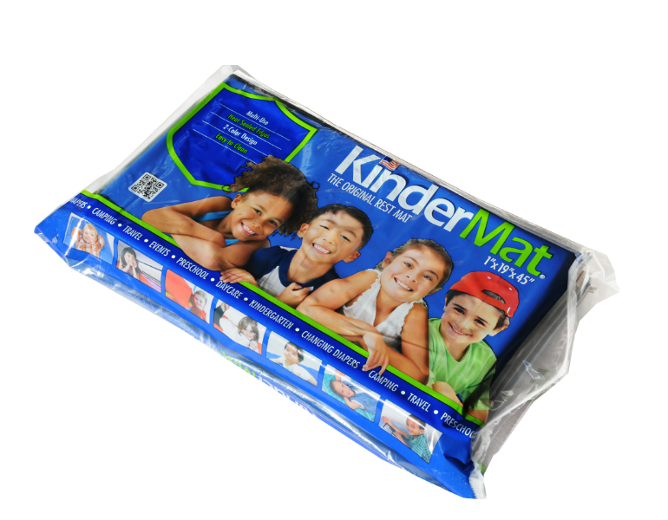rest mat

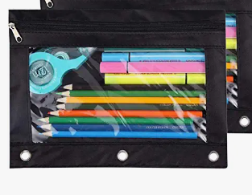 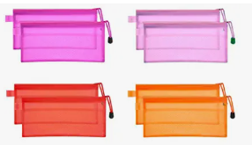 Zipper pencil bags
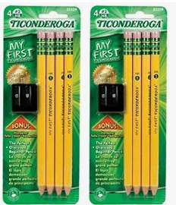 pencils
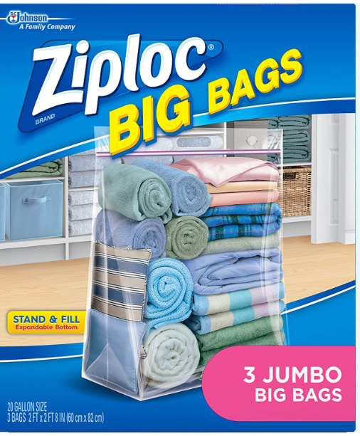 XXL Ziploc bag
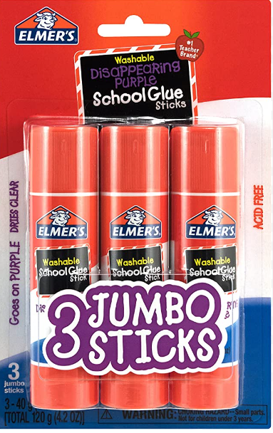 Glue sticks

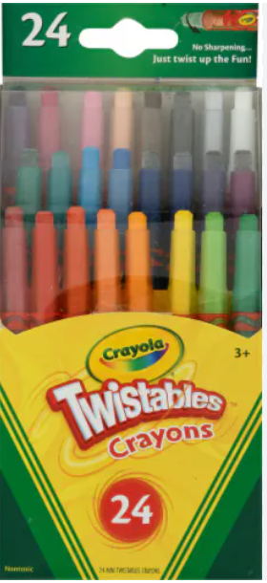 24 pack of Twistables

