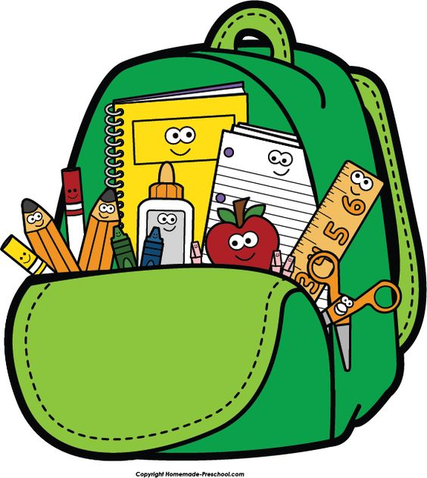

2023-2024
THIRD GRADE SCHOOL SUPPLY LIST
50 #2 pre-sharpened pencils (Ticonderoga, if possible)
2 sturdy pencil sharpeners
1 box crayons, 32 count
1 box of colored pencils, 36 count
1 box thin markers, 8 count
1 yellow highlighter
3 dry erase EXPO markers
3 large glue sticks
1 pair medium size scissors (7 inch or larger)
2-Pocket PLASTIC folders (1 of each): red, green, blue, orange, yellow, purple, and white
Wide-Ruled Composition Notebooks: Red, green, blue, orange, yellow, purple, and 2 white/black
1 wooden clipboard
1 box of sandwich size Ziploc bags
1 box of 2 gallon size Ziploc slider bags
1 pencil case with zipper
1 package of sheet protectors, 30 count

Spanish
2 glue sticks
1 composition notebook

